**Exploratory Data Analysis(EDA)**

**Assignment# 1**

**Submitted by: Junaid Solangi**

**Dataset Information:**

**Dataset Name: Food data (csv)**

**Source : Atomcamp**

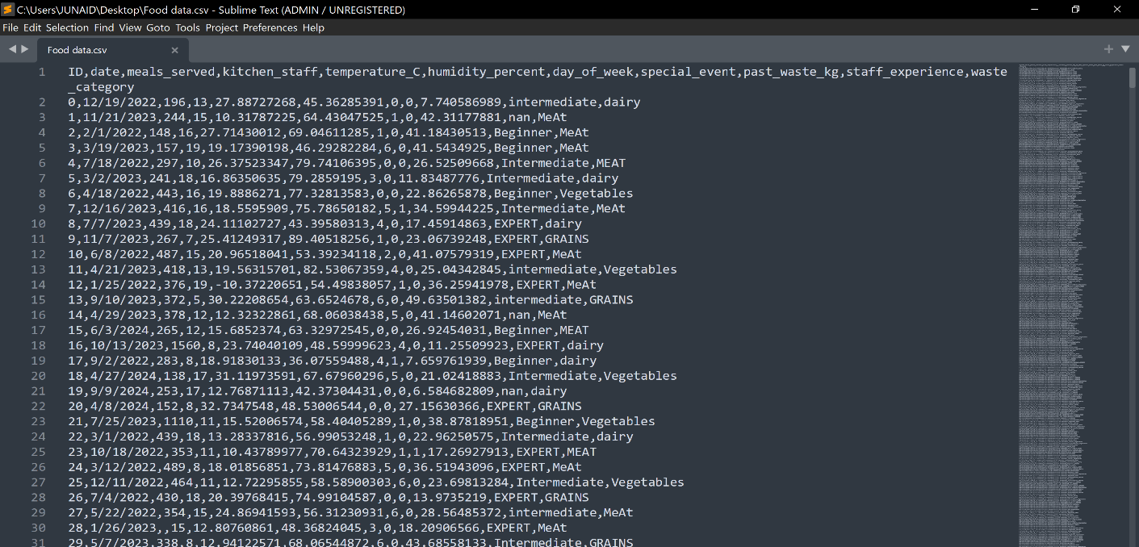

The dataset contains the following columns:

1. ID: A unique identifier for each record.

2. date: The date of the observation.

3. meals_served: The number of meals served on that day.

4. kitchen_staff: The number of kitchen staff working on that day

5. temperature_C: The temperature (in Celsius) on the recorded day.

6. humidity_percent: The humidity percentage on the recorded day.

7. day_of_week: The day of the week as a numeric value (0 = Sunday, 1 = Monday,

etc.).

8. special_event: A binary variable indicating whether a special event occurred (1

= event, 0 = no event).

9. past_waste_kg: The amount of food waste in kilograms from previous days.

10. staff_experience: The experience level of the kitchen sta

(e.g., "Beginner","Intermediate").

11. waste_category: The category of food waste (e.g., "dairy", "meat").

Libraries used in this assignment:

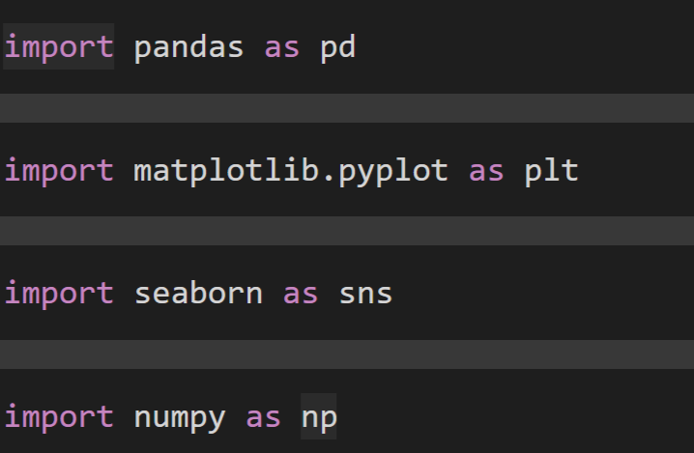

Exploring dataset:

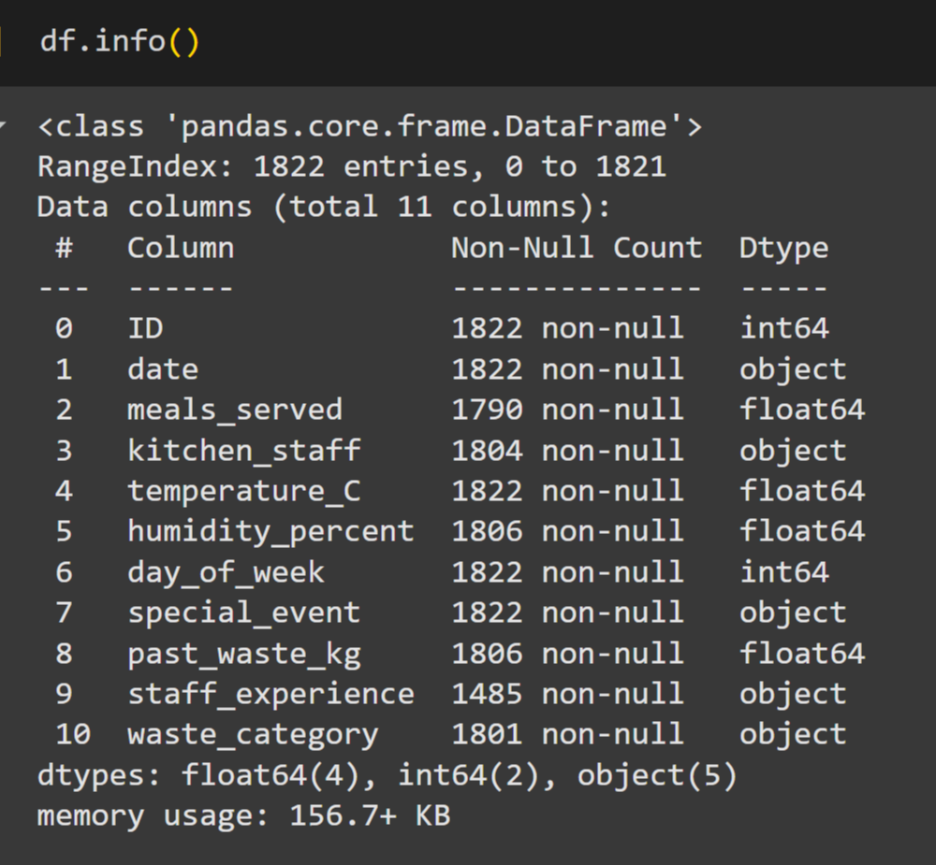

Getting rid of Duplicate records in the Dataset :

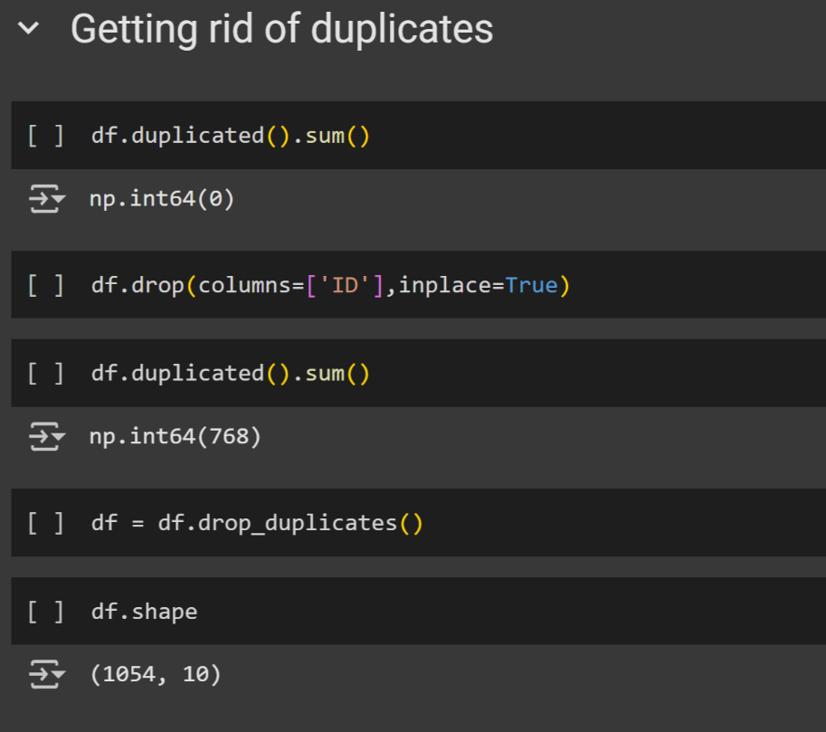

Correcting inconsistencies in variables:

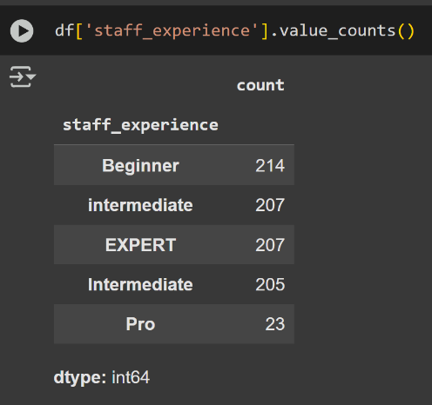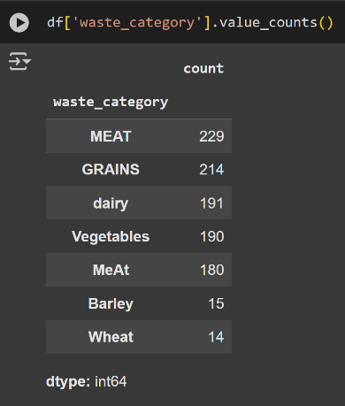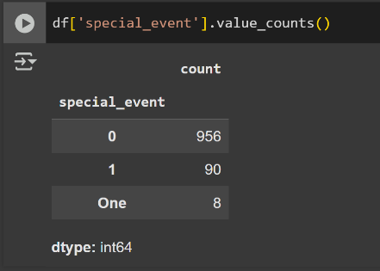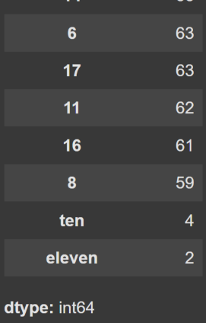

Code for correcting inconsistencies:

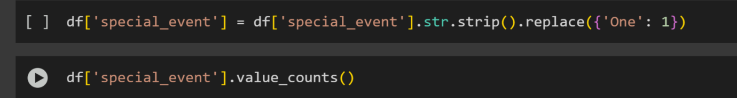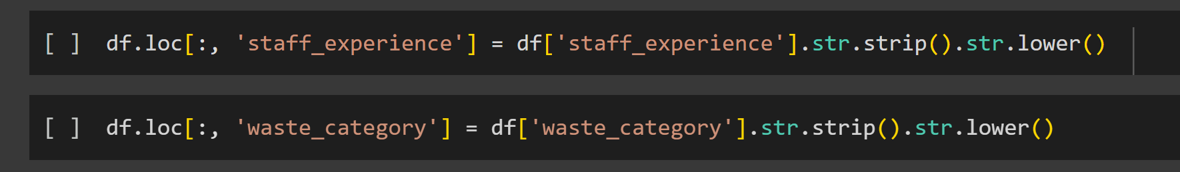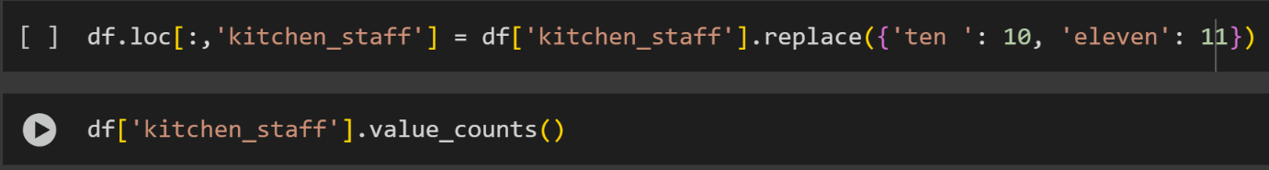

Results:

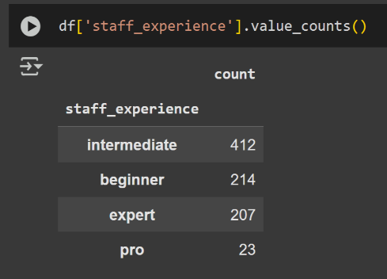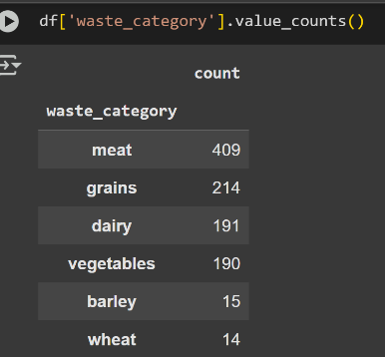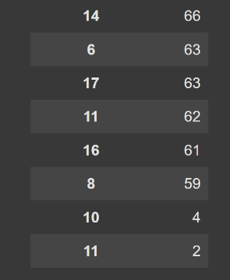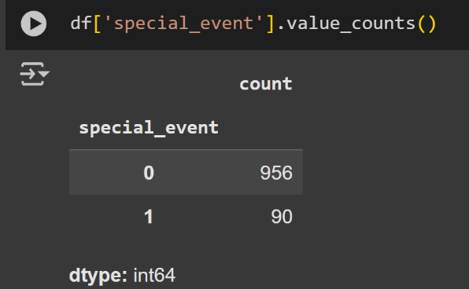

Missing data points:

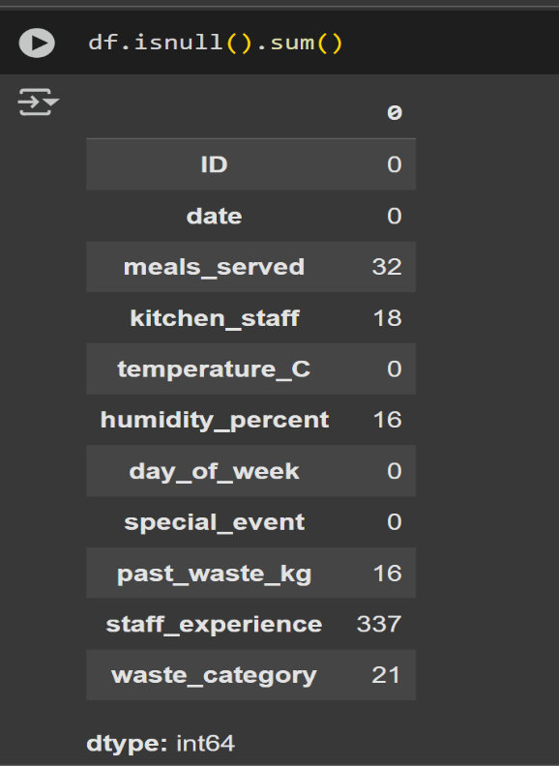

Here we can see columns: meals_served,kitchen_staff,humidity_percent,past_waste_kg,staff_experiance, waste_category are missing some data.

meals_served:

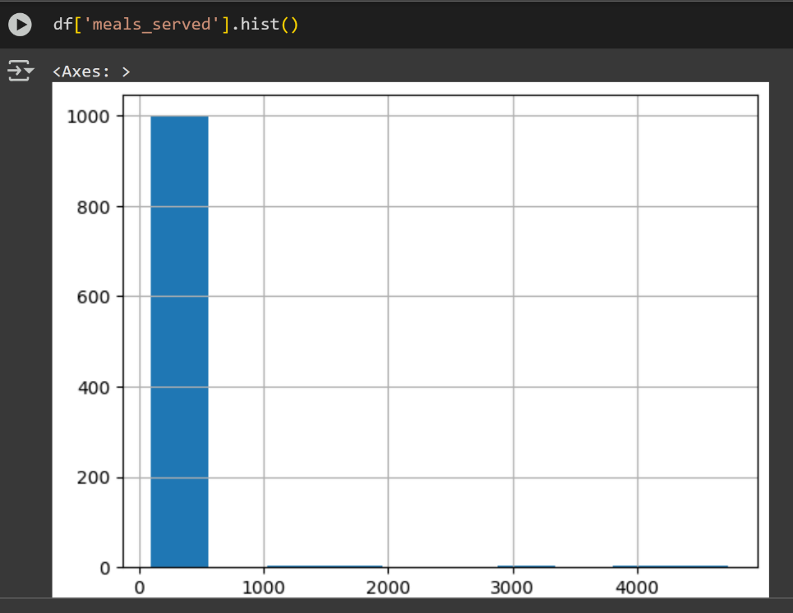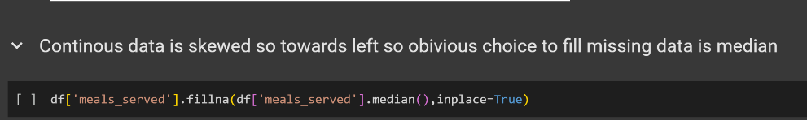

Kitchen_staff:

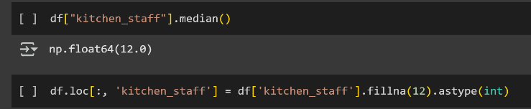

Waste_category:

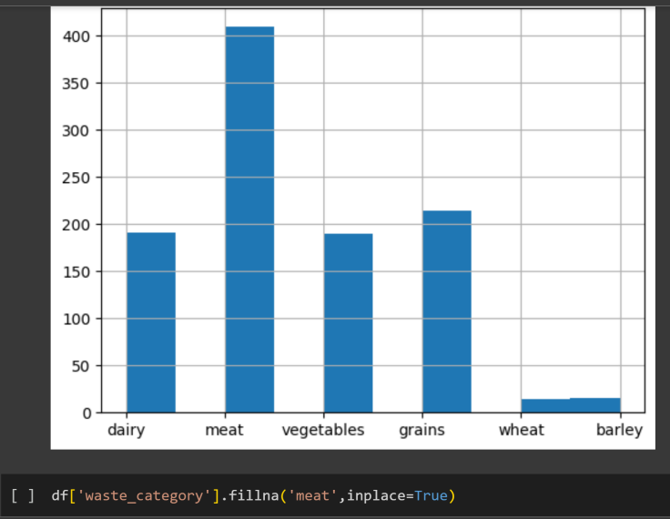

staff_experience:

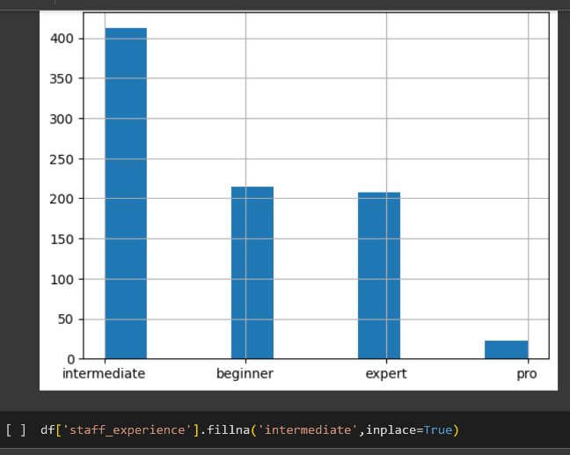

Past_waste_kg:

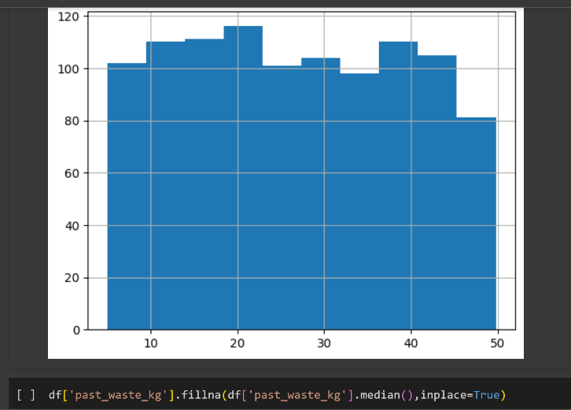

Humidity_percentage

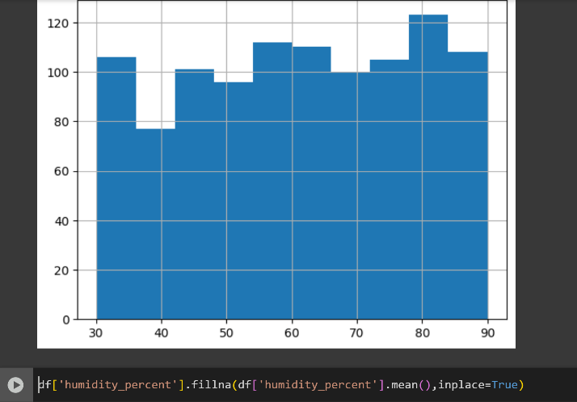

Outliers:

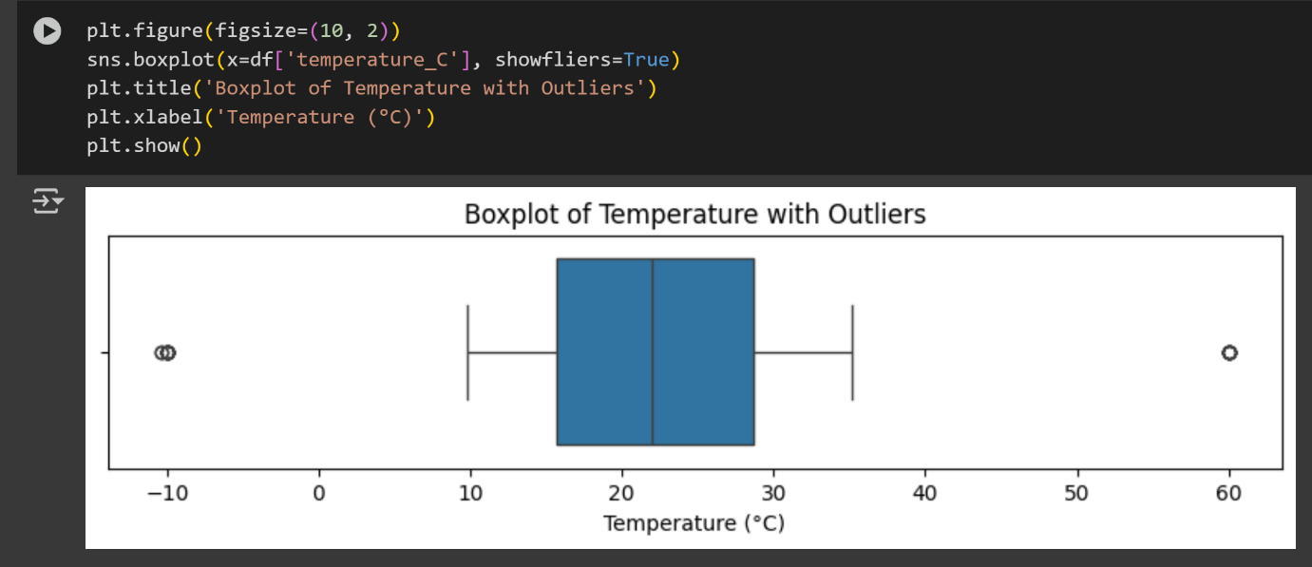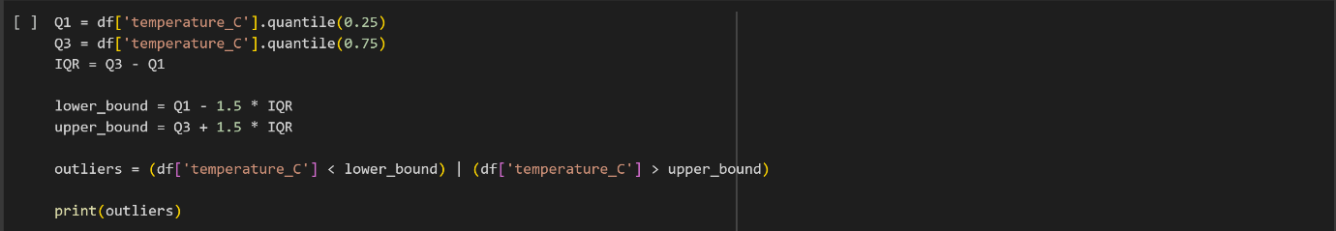

Caping the outliers:

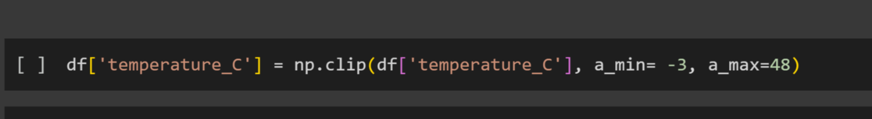

Ordering dataset according to date for time series analysis:

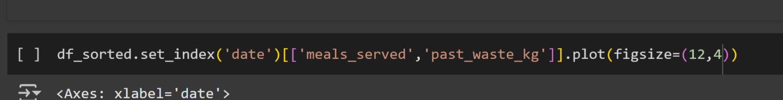

Time series analysis:

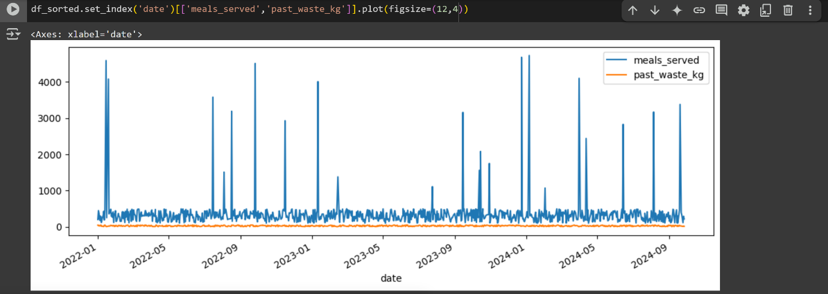

Analysing the spikes: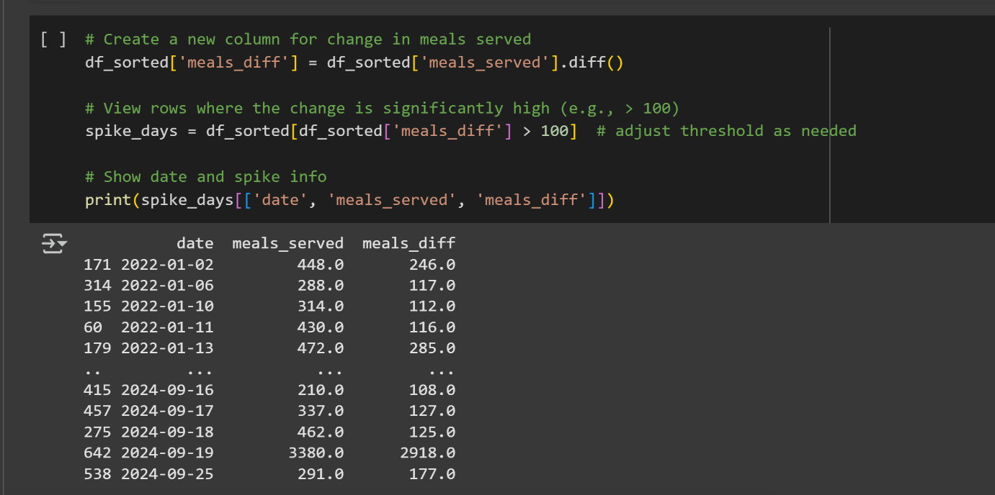

Results:

# Huge spikes (meals > 3000) appear on:

2022-01-15 and 2022-01-19

2022-07-16, 2022-08-17, 2022-09-26, 2022-12-24

2023-01-11, 2023-12-24, etc.

# Year-end holiday:

Dec 24 appears as a massive spike—likely Christmas Eve service, even if you’re not “celebrating” Christmas, many institutions run special buffet days or brunches.

# Mid-January:

Spikes on Jan 15 and Jan 19 may align with semester breaks, orientation weeks, or large training events starting after the New Year.

# Summer peaks:

Mid-July (July 16) and mid-August (Aug 17) spikes—could be summer camps, special programs, or Ramadan-related iftar buffets (Ramadan in 2022 was Apr 2–May 1; Eid al-Adha fell July 10–July 15).

**Creating Seasons for better analysis:**

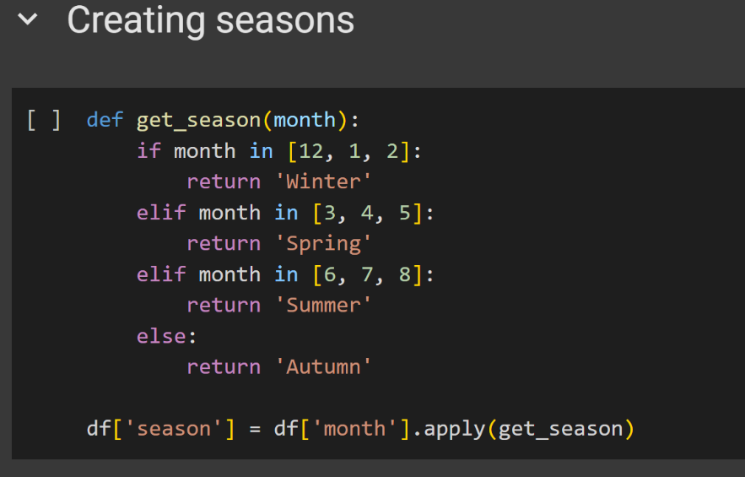

Heatmap:

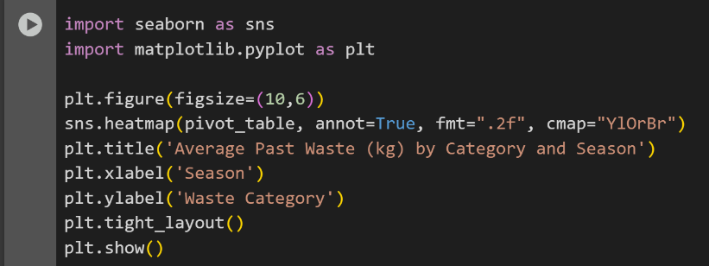

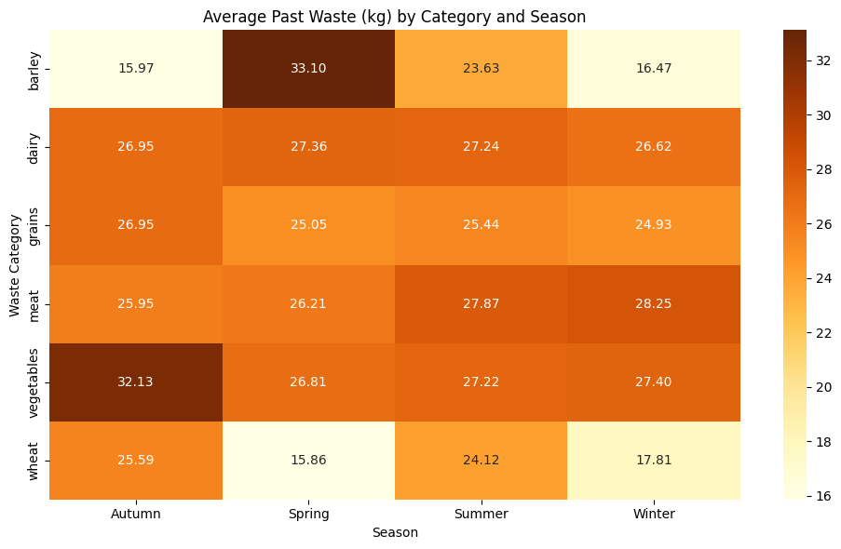

Results :

Insights

Highest Waste per Category:

Barley peaks in Spring (33.10 kg)

Dairy stays fairly stable across all seasons

Meat has the highest waste in Winter (28.25 kg)

Vegetables waste the most in Autumn

Wheat waste is lowest in Spring (15.86 kg) and Autumn (25.59 kg)

Categories with Strong Seasonal Swings:

Barley: from 15.97 (Autumn) to 33.10 (Spring) — significant spike

Wheat: from 15.86 (Spring) to 25.59 (Autumn)

Vegetables: Autumn is a peak (32.13 kg), other seasons are lower

Recommendations :

* Barley--Spring waste is highest (33.10 kg) ( Overstocking issue ) Reduce stock in Spring
* Dairy--Fairly consistent waste across all seasons (≈27 kg) Maintain steady inventory year-round,Monitor for spoilage-prone batches rather than adjusting seasonal quantity.
* Grains--Maintain slightly reduced inventory in Spring/Winter
* Meat--Highest waste in Winter (28.25 kg) Avoid overstocking meat in WinterTrack customer demand trends in Winter (may be lower than expected)
* Vegetables--Highest waste in Autumn (32.13 kg) Reduce vegetable stock in Autumn
* Wheat-- High waste in Autumn (25.59 kg) and Summer (24.12 kg) Lowest in Spring (15.86 kg) Stock less wheat in Autumn, Avoid excess ordering in Summer, Align stock with actual sales trends

**Waste vs Experience:**

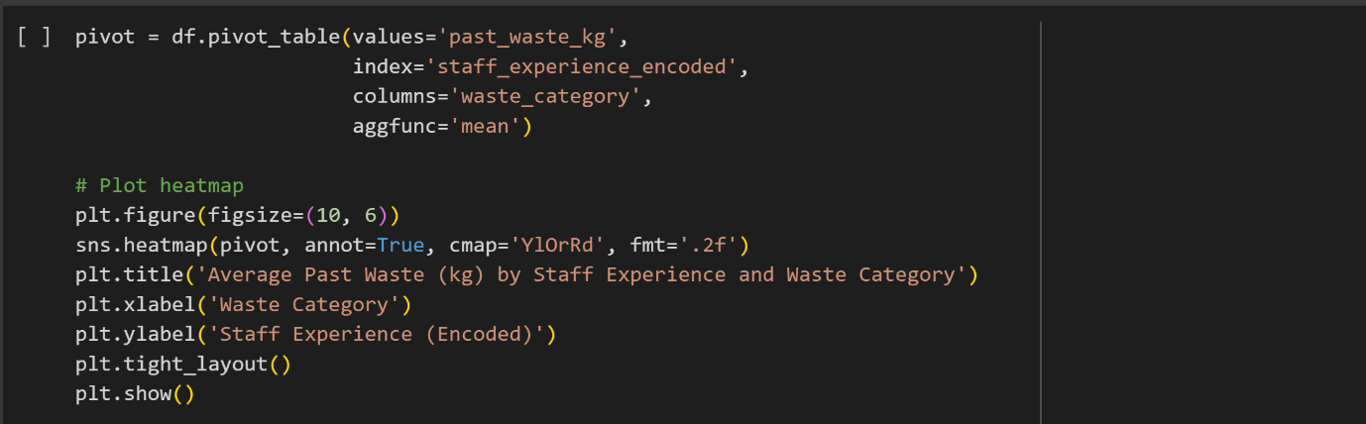

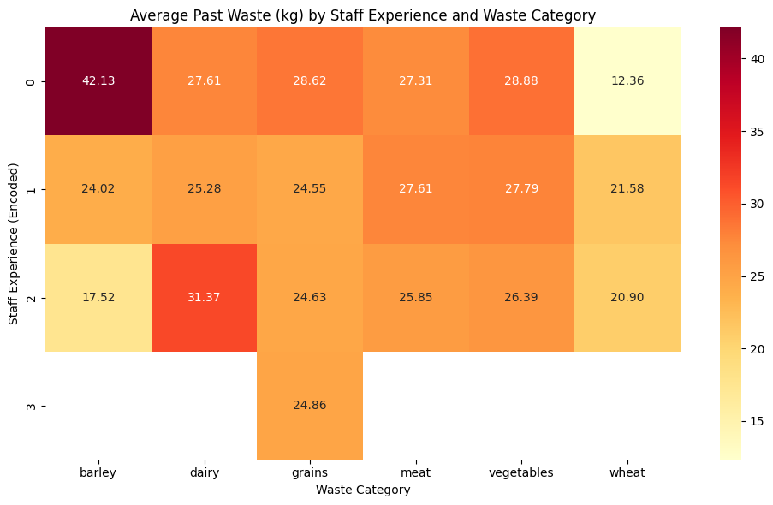

Results:

Insights

- Barley Waste dramatically decreases with more experienced staff:

From 42.13 kg (new staff) → 17.52 kg (experienced).

Suggests poor handling/prep of barley by new staff.

- Dairy Waste increases with experience:

Could be linked to prep-heavy menus used by experienced chefs (e.g., more dairy dishes or complex recipes).

Might be a menu planning issue, not staff skill.

- Grains and Meat Waste remain somewhat consistent across experience levels:

Training may not strongly influence these — may be storage or portion control related.

- Vegetables Waste gradually reduces with experience:Indicates that knife skills, storage, or portioning improve with experience.

- Wheat Waste increases from staff level 0 → 1 → 2:

Possibly due to increasing use of wheat in more complex dishes by mid/high-level staff.

Recommendations:

Train Beginner-Level Staff on Barley Handling Barley waste drops dramatically from 42.1 kg (Beginner) to 17.5 kg (Expert).

This suggests a steep learning curve for new staff.

Action Points:

Provide hands-on training in barley preparation.

Standardize measurement techniques.

Improve storage practices to reduce spoilage and overuse.

Audit Dairy-Intensive Dishes Prepared by Expert and Professional Staff Dairy waste increases with experience, peaking at the Expert level.

This may be due to complex, dairy-heavy recipes being handled by more experienced staff.

Action Points:

Review and simplify high-waste recipes.

Apply stricter portion control.

Track which dairy items are frequently discarded.

Create Waste-Specific SOPs for Grains, Vegetables, and Wheat Waste remains moderately high across all experience levels, showing room for improvement.

Action Points:

Develop Standard Operating Procedures tailored to each ingredient.

Reinforce proper storage, handling, and preparation techniques for each category.

Optimize Vegetable Handling in Beginner Onboarding Vegetable waste shows a steady decline with experience, highlighting training effectiveness.

Action Points:

Emphasize trimming techniques and storage protocols during onboarding.

Offer refresher courses on knife skills and prep efficiency.

Investigate High Wheat Waste Among Intermediate and Expert Staff Wheat waste increases from Beginner (12.36 kg) to Intermediate (21.58 kg) and Expert (20.90 kg).

This may point to issues with more complex wheat-based dishes.

Action Points:

Reassess recipes using wheat (e.g., bread, dough).

Identify if spoilage or over-preparation is contributing to the waste

Waste vs meals served



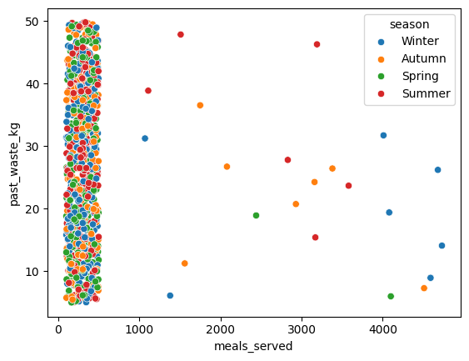

Meals served vs days :

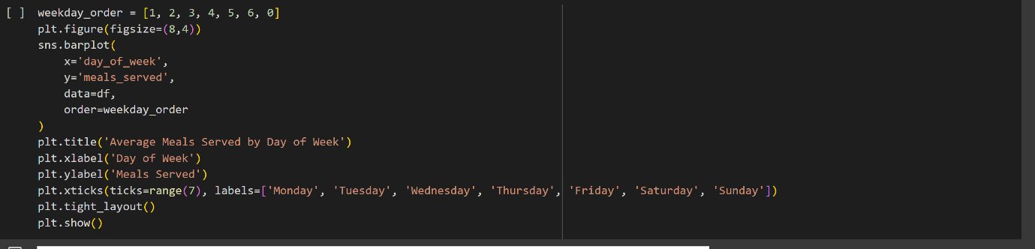

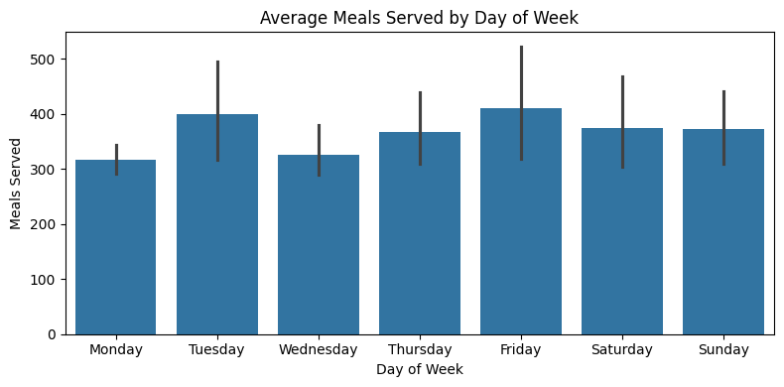

Meals served , waste vs Months:

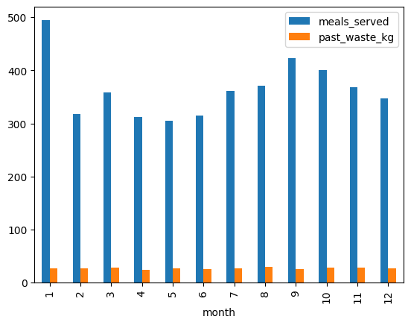

Correlation matrix:

